**TEMASEK POLYTECHNIC**

**SCHOOL OF INFORMATICS & IT**

**AY2022/2023 OCTOBER SEMESTER**

**DIPLOMA IN INFORMATION TECHNOLOGY**

**IOT APPLICATION DEVELOPMENT (CMC2C16)**

Project Proposal

|  |  |  |
| --- | --- | --- |
| Full Name | Admin No. | Class |
| Zhang Haorui | 2101806D | P06 |



**IoT Solution Name**

The IoT solution name is called Prove Me.

**Description**

Prove Me is an IoT solution that helps grocery and alcohol retailers conduct an age identity check on customers who have bought alcohol and/or tobacco products. Age identity checks are required for customers who are purchasing alcohol/tobacco products as stated in the Singapore Law.

Hence, with the implementation of Prove Me as an IoT solution to conduct automated, human-free age identity checks, Prove Me can assist retail workers in conducting necessary age identity checks on customers buying alcohol/tobacco products. This results in an overall more efficient, manpower-friendly, fast identity check experience.

Prove Me requires the customer who is paying for alcohol/tobacco products to position their faces in front of a camera.

The camera will then capture the customer’s image and runs through the SingPass or the Immigration Checkpoint & Authority face verification API and machine learning algorithms to verify the stored ID photo of the customer in the Government database and the face captured. Once verification is successful with the two images given, information about the customer such as name, date of birth and contact details will be retrieved.

With the date of birth information on hand, the information will then be passed on to a Lambda code, the code will then perform mathematical equations to calculate the exact age (in terms of years and months) of the customer.

If the customer is above the legal age to buy alcohol/tobacco products, the code will allow the customer to purchase the alcohol or tobacco products. If not above the legal age, it will decline the customer from purchasing the products.

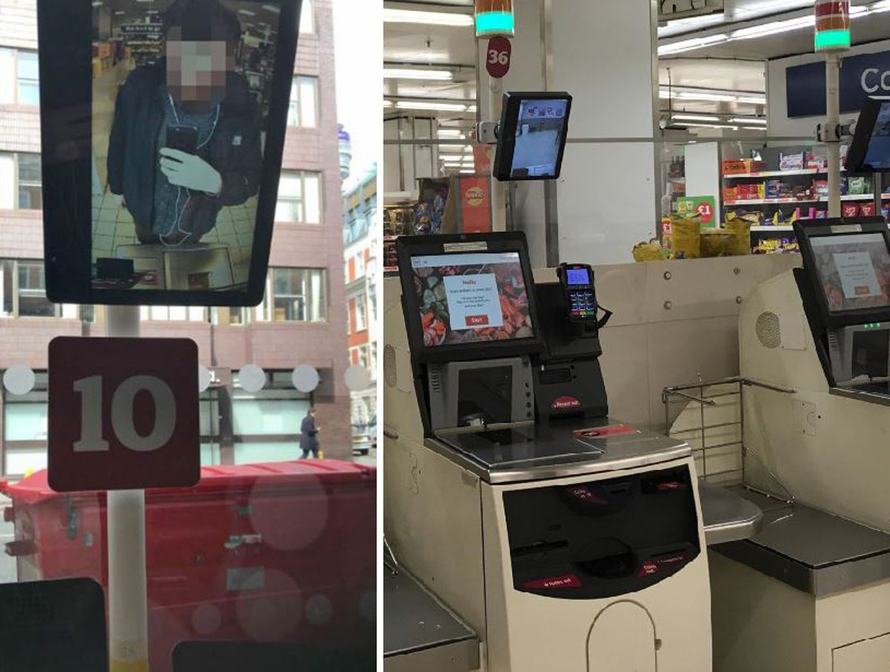 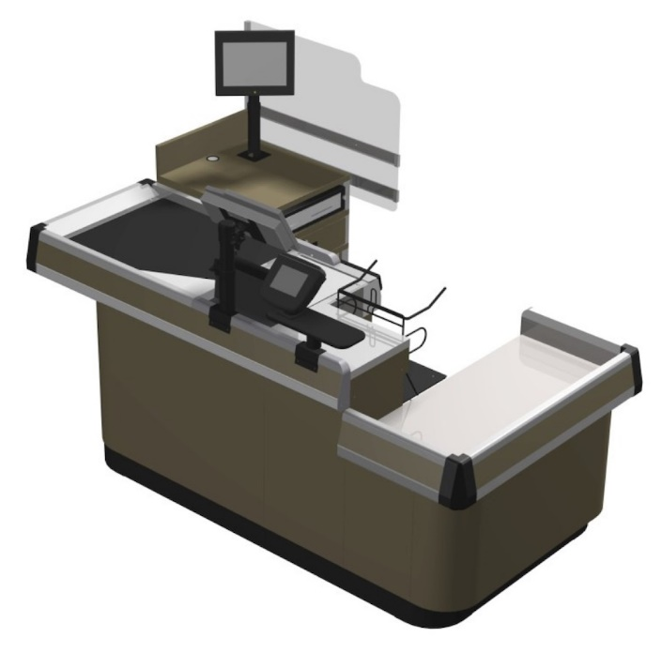

Camera Sensor & Price Display

Camera Sensor

*Pictures above: Implementation of Prove Me at self-checkout and manual checkout counters respectively.*

**Justification**

**Business Sector**

The business sector involved in using Prove Me is the retail industry, targeting the checkout experience, in terms of additional waiting time and transaction process at self-checkout or manual checkout counters, at any retail outlet.

With the IoT solution implemented, it allows a smooth-sailing checkout experience for customers, reducing unnecessary waiting time to wait for customers purchasing alcohol/tobacco to find and retrieve their identity cards from their wallet, and conducting manual age identity checks.

**Target Audience**

Prove Me aims to target clients from the retail industry such as supermarket companies where it caters to a variety of customers who shops frequently to buy grocery items. Prove Me can be installed at manual and self-checkout counters to assist in identity checks on alcohol/tobacco products.

Instead of relying on human interaction to conduct identity checks on alcohol or tobacco products, supermarket companies can adopt Prove Me as their IoT solution to automate and digitalise the process of identity checks, which will identify whether the customer purchasing the restricted products is allowed or not allowed to purchase the items.

In conclusion, Prove Me not only reduces waiting times and frustration among customers with their checkout experience but also requires lesser manpower involved as identity checks are now digitalised and automated.

**Need for IoT Solution**

Case Study 1 – Convenience & Hassle-Free

In Singapore, facial recognition technology is also implemented on the Singpass website application login, which is a new alternative to logging in aside from two-factor authentication (2FA). Using facial recognition features reduces necessary touchpoints, which is the need to unlock the registered phone to view and key in additional One-Time Passwords (OTPs), which can be a hassle to some people.

Similarly, bringing IC and mobile phones will not be required if customers wish to purchase alcohol/tobacco products. All they need to do is have their face present in front of the camera and in which will verify if the customer is above the legal age to purchase such alcohol/tobacco products. In return, customers will not have to worry about losing their IC cards or mobile phones, which are essential and private documents when heading outside.

Case Study 2 – Use of Facial Recognition in other sectors

Facial recognition technology is already implemented in other industries, such as the aviation industry and the New York City Government.

Security checkpoints in airports are adding more facial recognition technology at the immigration checkpoints, with a probability from the US Department of Homeland Security that 97% of travellers will encounter and utilise facial recognition technology for the immigration verification process by 2023.

In addition, the U.S. Customs and Border Protection has also concluded that facial recognition is more accurate and effective in conducting and reducing waiting times for customs checks. For instance, a manual verification (officer check) takes around 10 to 30 seconds while facial recognition technology takes around 2 to 3 seconds to verify a traveller. This means that facial recognition technology is 90% faster compared to manual verification.

This case study solution is very similar to Prove Me. Retail workers, who face the challenge to read and verify the low-resolution passport image and small characters of IC cards (date of birth), and do not have the experience of looking at outdated IC photos, will probably face difficulty in identifying a customer purchasing alcohol/tobacco products. With similar IoT solutions to Prove Me already implemented in other sectors and with positive results shown, Prove Me will be able to tackle exploitations and automate the process of identity checks for retail outlets.

**Benefits**

Efficient (Tangible)

Prove Me will be able to speed up the process of conducting identity checks on customers.

This is proven by a similar concept happening in airports around the globe. The idea is instead of using a staff member to verify a passenger’s boarding pass with the identity of the passenger using passport verification, an automated equipped with a camera and a display will authenticate the passenger’s identity with the airline database.

An insight found during a trial conducted by British Airways and US Customs and Border Protection is that this automation technology, similar to Prove Me solution, has been able to verify 240 customers in around 10 minutes, which means that the facial recognition system takes approximately 2 seconds to verify a customer. Moreover, its accuracy rate for identifying customers is 98%.

This suggests that facial recognition technology is very efficient and accurate, and hence Prove Me, which will adopt the facial recognition technology found in airports, will provide customers with a smooth and fast identity check when purchasing alcohol/tobacco products.

Reduced Touchpoints (Intangible)

With the implementation of Prove Me as an IoT solution at checkout counters, customers purchasing alcohol/tobacco products will realise that the number of touchpoints has been reduced.

Before implementing Prove Me facial recognition technology, customers who purchase alcohol/tobacco products will need to take their wallet or mobile phone out to present their identity card to a cashier to verify their age.

However, after implementing Prove Me, customers do not need to take out their wallets to present their identity cards. Instead, they only need to present their face in front of a camera to verify their identity and age.

In general, customers will not need to bring confidential documents around when shopping. Moreover, retail workers will not need to squint their eyes to look at the small characters on the identity card.

**Scope**

Once the customer or staff member completely scans the entire cart of items, Prove Me will start running by scanning through the cart items for alcohol/tobacco products.

If there are no alcohol/tobacco items in the payment basket, Prove Me will return a False statement and redirect the checkout machine to the payment page. The paying customer will not need his/her face to be scanned.

However, if there are alcohol/tobacco items in the payment basket, Prove Me will return a True statement in which the paying customer will have to do facial recognition via a camera.

The face image captured by the camera will then be run through the face recognition deep learning algorithm, similar to the SingPass face verification function, and will be compared with stored images from the Immigration Checkpoint Authority database.

After comparing the image captured by the camera with the face image stored in the authority’s database, it will find the correct identity of the customer who is purchasing the alcohol/tobacco products by matching the two images provided.

If there is a successful match of the images provided, Prove Me will be able to retrieve the personal information of the purchasing customer such as name, NRIC, and date of birth from the authority’s database. The date of birth of the customer will then be parsed into a code to calculate and validate whether the customer is above the legal age to purchase alcohol/tobacco.

**Scenario 1:** If the customer is not above the legal age to purchase alcohol/tobacco products, a message will be displayed to inform the customer that he/she is not at the legal age to purchase those products. This means that the customer will not be able to purchase the restricted items.

**Scenario 2:** If the customer is above the legal age to purchase alcohol/tobacco products, Prove Me will direct the customer to the payment page and will store data in the AWS DynamoDB database.

The data stored will include the customer’s name, NRIC, name of the restricted product purchased, type of the restricted product purchased (alcohol or tobacco cigarettes), date/time of the purchase and passport image of the customer. The purpose of storing these data is to assist the company’s audit process and comply with relevant authorities should there be an investigation needed. The image captured will also be uploaded to an AWS S3 bucket.

If there is an unsuccessful match of the images provided, Prove Me will return an error message to inform the customer and staff of the issue. They can choose to either re-capture the purchasing customer’s face via the camera or require a staff member to conduct a manual identity check on the customer. It will then utilise AWS CloudWatch & Simple Notification Service to log the error information and notify developers of the error.

Verification Failed

Error Message

Request help

Verification Success

*Pictures above: Result message after doing the facial identity check.*

**Limitations**

Accuracy Rate

Despite the facial recognition technology having the ability to verify people 98% of the time accurately, there is still the 2% which could not verify accurately. One such factor causing the 2% inaccuracy could be the camera angle. To identify a face, the technology will need to look at multiple angles, such as frontal, 45 degrees and more, to ensure accurate resulting matches.

In addition, any obstructions such as facial hair, hats, sunglasses, or any changes to the face can cause the facial recognition technology to have some issues in matching the photo taken and the passport image from the authority’s database.

To combat the two problems mentioned, Prove Me can inform customers to note some instructions or requirements before the automated facial identity check is conducted. Prove Me will also remind customers to update their passport photo at the relevant authority (ICA) to ensure the passport image in the authority’s database is frequently updated.

*Picture above: An informative guide before doing the facial identity check.*

Consent & Privacy

For internal company audit purposes, customer names, NRIC, date of birth, name of the restricted product purchased, type of the restricted product purchased (alcohol or tobacco cigarettes), and date/time of the purchase will be logged into the database. As such, some customers may be worried that their personal data might be exposed in the event of a data breach, resulting in them opting out of the facial identity check.

To mitigate the issue of privacy, Prove Me will provide the customer with the option to choose whether to conduct an automated facial identity check or a manual identity check by a retail worker. Customers will also be informed that their personal details will be deleted from the database 6 to 12 months after their date of purchase should they opt for an automated facial identity check.

**AWS Diagram**

**References**

<https://www.straitstimes.com/singapore/retailers-face-intensified-manpower-crunch-amid-post-pandemic-recovery>

<https://edition.cnn.com/travel/article/airports-facial-recognition/index.html>

<https://www.nytimes.com/2022/02/26/travel/facial-recognition-airports-customs.html>

<https://www.itpro.com/security/privacy/356882/the-pros-and-cons-of-facial-recognition-technology>

<https://itrexgroup.com/blog/facial-recognition-benefits-applications-challenges/#>

<https://www.forbes.com/sites/bernardmarr/2019/08/19/facial-recognition-technology-here-are-the-important-pros-and-cons/?sh=11db01b114d1>

<https://becominghuman.ai/the-threats-and-benefits-of-facial-recognition-what-should-we-know-17008f69ae74>

<https://www.techfunnel.com/information-technology/5-pros-and-cons-of-face-recognition-technology/>